|  |
| --- |
| EPAM Systems, RD Dep. |
| MTN.BI.08 PL/SQL Techniques |

|  |  |  |  |  |  |
| --- | --- | --- | --- | --- | --- |
| REVISION HISTORY | | | | | |
| Ver. | Description of Change | Author | Date | Approved | |
| Name | Effective Date |
| 1.0 | Initial status | [Kiryl Bucha](mailto:Kiryl_Bucha@epam.com) | 12-JAN-2012 |  |  |
| 2.0 | Updated in accordance with renewed content | [Elias Nema](mailto:Elias_Nema@epam.com) | 20-JAN-2014 |  |  |
| 3.0 | Report on task | Hanna Klimovich | 02-DEC-2017 |  |  |

Contents

1. Create Packages for Reload Dimension from DW to SAL 3

2. Test Your Data 3

3. Task Results 3

# Create packages to load dimensions from ST (staging) to SL (star layer)

The Main Task is to create independent packages to reload dimensions according to your DWH solution concept that was developed on Module 6 Introduction to DWH.

Required points:

* Create all required dim objects on SL Layer
* Grant all required privileges to SL_CL (Cleansing Layer)
* Create packages to load dim data (one package = one dimension) on SL_CL
* Use Bulk Collect (One or more procedures)
* Use Forall (One or more procedures)
* Use a cursor FOR loop
* Use EXECUTE IMMEDIATE INTO for dynamic queries
* Use cursor variables

# Test Your Data

Prepare document with screenshots of the data on different layers. Test data for the consistency:

* Reload packages on the same data (nothing should be changed).
* Reload packages with some changes to test if your SCD logic works as expected.

Create document with description and pictures about testing your data.

To create tables and load data to dimensions:

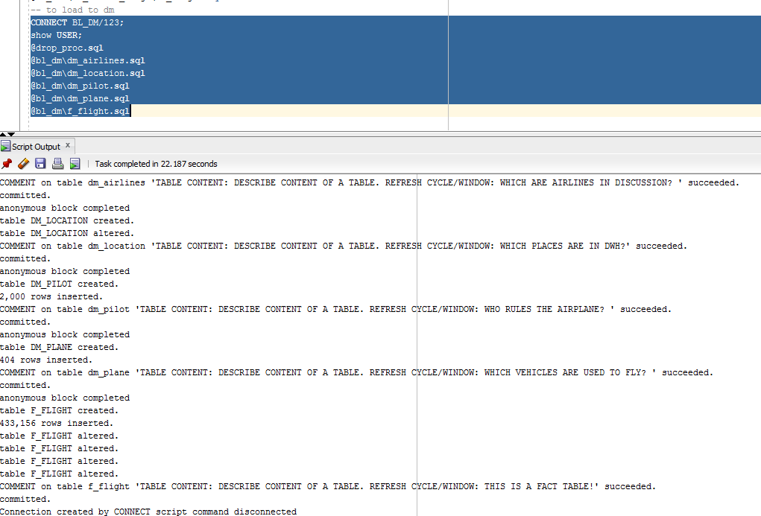

Script example of creation and loading data:

